Lagged cross-correlation: USDCHF and EURGBP
Method 12 / daily log returns / K_max=10 / Alpari D1 full available history

Study setup
Logical pair: USDCHF , EURGBP
Broker symbols: USDCHF_i , EURGBP_i
Snapshot: 2026-11-03_majors_alpari_D1
Timeframe: D1
Matched return window: 1999-01-06 to 2026-11-02 (UTC bar dates)
Matched return count n: 7182
Dropped unfinished last bar dated 2026-11-03 UTC after a tick-volume check against the prior complete day.
Lag definition: rho_X->Y(k) = Corr(x_t, y_{t+k}) on matched D1 bars
K_max = 10; headline lag k = 1 (both directions)
Complete matched rows (Excel): USDCHF-EURGBP_Lagged_D1.xlsx
Complete matched rows (HTML table): USDCHF-EURGBP_Lagged_D1_data.html

Method carried forward
Lagged cross-correlation measures Pearson correlation between matched daily log returns of close, ln(close_t / close_t-1), after shifting one series forward by k bars on the matched panel. Quotes are not inverted. rho_{X->Y}(k) = Corr(x_t, y_{t+k}) with n_k = n - k. K_max = 10 is fixed before estimation. The headline is the pre-specified lag k = 1 in both directions. k = 0 is the same-bar side check. The lag inside 1..10 with the largest absolute rho is stored as a descriptive column only; it is not a selected result. This is a linear screen, not proof of forecast edge, economic cause, or a trading signal.

Results (headline k=1)
rho_USDCHF->EURGBP(1): 0.029865 (n=7181)
95% Fisher interval USDCHF->EURGBP: [0.006740, 0.052958]
rho_EURGBP->USDCHF(1): 0.017331 (n=7181)
95% Fisher interval EURGBP->USDCHF: [-0.005801, 0.040444]
Same-bar rho(k=0): -0.325886
Largest |rho| among k=1..10 (descriptive only, not selected): USDCHF->EURGBP k=9 rho=0.033595; EURGBP->USDCHF k=4 rho=-0.026717

CCF table
k | rho_USDCHF_to_EURGBP | n_USDCHF_to_EURGBP | rho_EURGBP_to_USDCHF | n_EURGBP_to_USDCHF
0 | -0.32588645 | 7182 | -0.32588645 | 7182
1 | 0.02986539 | 7181 | 0.01733105 | 7181
2 | -0.00271687 | 7180 | -0.0101706 | 7180
3 | 0.00393942 | 7179 | 0.02041012 | 7179
4 | -0.00403953 | 7178 | -0.02671746 | 7178
5 | 0.00920865 | 7177 | -0.0074902 | 7177
6 | 0.02270183 | 7176 | -0.01080987 | 7176
7 | 0.00999742 | 7175 | -0.00261229 | 7175
8 | 0.0015555 | 7174 | -0.02557323 | 7174
9 | 0.03359496 | 7173 | -0.0069883 | 7173
10 | -0.00822716 | 7172 | -0.01417603 | 7172

Conclusion
At the pre-specified lag k=1 for USDCHF and EURGBP, rho_{USDCHF->EURGBP}(1) = 0.0299 (n=7181) and rho_{EURGBP->USDCHF}(1) = 0.0173 (n=7181). Same-bar rho(k=0) = -0.3259. Largest |rho| among k=1..10 is descriptive only: USDCHF->EURGBP at k=9 (0.0336); EURGBP->USDCHF at k=4 (-0.0267). This is a linear screen, not forecast proof or a trading signal.

Charts
Daily closes

Daily log returns

CCF both directions k=0..10
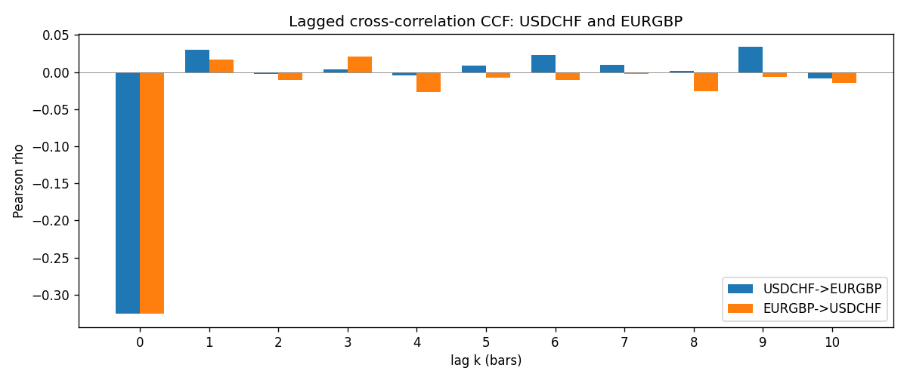

Data report
Every matched row is stored in the sibling Excel workbook named USDCHF-EURGBP_Lagged_D1.xlsx (sheet matched_rows). The CCF sheet holds rho(k) for k=0..10. Embedding all rows as a Word table is impractical; the Word file holds column summaries and the first and last 15 rows.
Columns: time, USDCHF_open, EURGBP_open, USDCHF_high, EURGBP_high, USDCHF_low, EURGBP_low, USDCHF_close, EURGBP_close, USDCHF_tick_volume, EURGBP_tick_volume, USDCHF_spread, EURGBP_spread, USDCHF_real_volume, EURGBP_real_volume, USDCHF_log_return, EURGBP_log_return
Column summaries (matched calculation rows)
column | count | mean | std | min | 25% | 50% | 75% | max
USDCHF_open | 7182 | 1.0972493 | 0.25210985 | 0.72022 | 0.9204925 | 0.989875 | 1.237175 | 1.8219
EURGBP_open | 7182 | 0.7869939 | 0.09664695 | 0.5734 | 0.6877 | 0.833905 | 0.865225 | 0.9769
USDCHF_high | 7182 | 1.1025378 | 0.25385182 | 0.73305 | 0.924695 | 0.99351 | 1.242175 | 1.8313
EURGBP_high | 7182 | 0.79007306 | 0.09702085 | 0.5789 | 0.6897 | 0.836955 | 0.8681 | 0.9799
USDCHF_low | 7182 | 1.092133 | 0.25052689 | 0.08565 | 0.9171825 | 0.986205 | 1.2312 | 1.8121
EURGBP_low | 7182 | 0.7842938 | 0.09646529 | 0.5682 | 0.685725 | 0.83166 | 0.86287 | 0.9661
USDCHF_close | 7182 | 1.09724 | 0.25200902 | 0.72025 | 0.9207375 | 0.98991 | 1.23715 | 1.8217
EURGBP_close | 7182 | 0.78703952 | 0.09664503 | 0.5735 | 0.687825 | 0.83398 | 0.865375 | 0.977
USDCHF_tick_volume | 7182 | 74362.695 | 113509.88 | 18 | 12814.25 | 40258.5 | 70446 | 858589
EURGBP_tick_volume | 7182 | 87145.49 | 145506.26 | 154 | 6593.75 | 44371 | 81432 | 1424684
USDCHF_spread | 7182 | 26.020746 | 24.692144 | 0 | 5 | 16 | 50 | 100
EURGBP_spread | 7182 | 21.320663 | 19.117614 | 0 | 4 | 13 | 40 | 50
USDCHF_real_volume | 7182 | 2.3303821e+10 | 8.915094e+10 | 0 | 0 | 0 | 0 | 1.9331921e+12
EURGBP_real_volume | 7182 | 2.7876168e+10 | 1.3522356e+11 | 0 | 0 | 0 | 0 | 3.5726265e+12
USDCHF_log_return | 7182 | -7.199e-05 | 0.00659004 | -0.19545699 | -0.00335239 | 7.626e-05 | 0.00331734 | 0.09051364
EURGBP_log_return | 7182 | 2.529e-05 | 0.00487429 | -0.03067367 | -0.00262165 | -0.00010006 | 0.00256425 | 0.06075387
First 15 matched rows (selected columns)
time | USDCHF_close | EURGBP_close | USDCHF_log_return | EURGBP_log_return
1999-01-06 | 1.3912 | 0.7019 | 0.013605652 | -0.013303338
1999-01-07 | 1.3782 | 0.7097 | -0.0093883841 | 0.011051402
1999-01-08 | 1.3935 | 0.7062 | 0.011040268 | -0.004943862
1999-01-11 | 1.4009 | 0.7053 | 0.0052963193 | -0.0012752393
1999-01-12 | 1.3872 | 0.7077 | -0.0098275602 | 0.0033970309
1999-01-13 | 1.3621 | 0.708 | -0.018259701 | 0.00042381861
1999-01-14 | 1.3588 | 0.7066 | -0.0024256692 | -0.0019793588
1999-01-15 | 1.3834 | 0.7012 | 0.01794228 | -0.0076715819
1999-01-18 | 1.379 | 0.7017 | -0.0031856384 | 0.00071280921
1999-01-19 | 1.3789 | 0.7007 | -7.2518946e-05 | -0.0014261269
1999-01-20 | 1.3889 | 0.7021 | 0.0072259871 | 0.0019960086
1999-01-21 | 1.3836 | 0.7016 | -0.0038232689 | -0.00071240297
1999-01-22 | 1.3834 | 0.7004 | -0.0001445609 | -0.0017118406
1999-01-25 | 1.3868 | 0.6966 | 0.0024546976 | -0.0054402425
1999-01-26 | 1.3897 | 0.6962 | 0.0020889617 | -0.00057438255
Last 15 matched rows (selected columns)
time | USDCHF_close | EURGBP_close | USDCHF_log_return | EURGBP_log_return
2026-10-13 | 0.83244 | 0.84458 | -0.0024955621 | 0.00020130374
2026-10-14 | 0.83489 | 0.84553 | 0.0029388325 | 0.0011241873
2026-10-15 | 0.82676 | 0.84479 | -0.0097855323 | -0.00087557391
2026-10-16 | 0.82377 | 0.84307 | -0.0036230826 | -0.0020380844
2026-10-19 | 0.82677 | 0.84259 | 0.0036351779 | -0.00056950988
2026-10-20 | 0.8246 | 0.83957 | -0.0026281224 | -0.0035906254
2026-10-21 | 0.82427 | 0.83839 | -0.00040027413 | -0.00140647
2026-10-22 | 0.82032 | 0.83682 | -0.0048036381 | -0.0018743924
2026-10-23 | 0.82497 | 0.83751 | 0.005652514 | 0.00082421033
2026-10-26 | 0.82649 | 0.83762 | 0.0018407959 | 0.00013133309
2026-10-27 | 0.82865 | 0.83595 | 0.0026100526 | -0.0019957343
2026-10-28 | 0.82781 | 0.83651 | -0.0010142111 | 0.00066967224
2026-10-29 | 0.82379 | 0.83553 | -0.0048680164 | -0.0011722209
2026-10-30 | 0.82438 | 0.83351 | 0.00071594559 | -0.0024205543
2026-11-02 | 0.81851 | 0.83426 | -0.0071459744 | 0.00089940465

